India's Historic Win – The World Cup 1983

India’s 1983 World Cup win was a historic moment in the game’s tradition. It was the makings of a new superpower in the world of cricket. It added a chapter to a long list of famous underdog stories sports across the world has and it give India the audacity to dream.
The squad and Match Structure
Going by India's past record in one-day internationals and in the World Cup, they were not expected to even progress beyond the Group stage of the 1983 Cricket World Cup which was yet again held in England, despite having the likes of Sunil Gavaskar, Krishnamachari Srikkanth, Dilip Vengsarkar, Yashpal Sharma and Sandeep Patil in batting and a decent set of all-rounders in captain Kapil Dev, who was now one of the best all-rounders in world cricket, Mohinder Amarnath, Madan Lal, Ravi Shastri and Roger Binny.
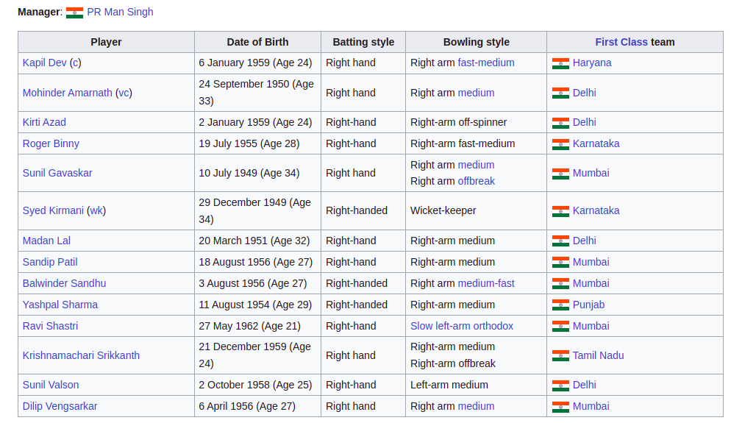
This time, the tournament format was slightly different from the previous editions. Teams were still divided among 2 groups of 4, but now each team in a group played each other twice. India were placed in Group B in the Group stage, which was considered to be the tougher of the 2 groups as it included 2 stronger opponents in the defending champions, the West Indies, whose dominance in world cricket at the time was at its peak, and Australia. World Cup debutants Zimbabwe were also in the group. The fact that the West Indies and Australia were in India's group only worsened India's prospects of putting a decent showing this time around.
Group stage Matches
India's first match in the tournament was against the West Indies at Old Trafford in Manchester. The West Indians were expected to steamroll India, but India caused a massive upset, winning the game by 34 runs in a match spread over 2 days. Middle-order batsman Sharma withstood the West Indian pace attack to score a fine half-century (89 from 120 balls, 9 fours) as India scored 262/8. Then, a disciplined performance from the Indian bowlers led by all-rounders Binny (3/48) and Shastri (3/26) ensured that the West Indian batsmen could not settle down after their starts, as a result of which the West Indies were bowled all out for 228. India followed this victory with another win against Zimbabwe at Leicester. In a one-sided match, India, bowling first, restricted Zimbabwe to 155 with Madan Lal taking 3/27, following which a half-century by Patil (50 from 54 balls, 7 fours, 1 six) ensured that India chased down the paltry total easily.
However, despite the good start, 2 consecutive defeats against Australia at Trent Bridge in Nottingham and the West Indies at The Oval in London followed, and with other results going Australia's and the West Indies' way, India were once again staring at another early exit from the World Cup. Trevor Chappell scored 110 to ensure that Australia scored a mammoth 320/9, with India dishing out a listless bowling performance. Only Kapil bowled well, taking a 5-wicket haul (5/43). Australian medium-pacer Ken MacLeay took 6/39 as India were bowled all out for just 158, losing by 162 runs, with none of the Indian batsmen contributing. Against the West Indies, India, chasing 283 to win, never really got going despite Amarnath's patient knock (80 from 139 balls). A combined effort from the West Indian pace attack saw India crash to 216 all out, losing by 66 runs. To add to India's woes, Vengsarkar was ruled out for the rest of the tournament after a Malcolm Marshall bouncer injured his jaw. To reach the semifinals now, India had to beat Zimbabwe and Australia by huge margins, a daunting prospect. Should India lose even one of the matches, they would be knocked out of the tournament.
India began their match against Zimbabwe at Tunbridge Wells on 18 June 1983 disastrously. The Zimbabwean bowling attack, led by Peter Rawson (3/47) and Kevin Curran (3/65), destroyed the Indian top order, reducing them to 17/5. A massive upset by the Zimbabweans and another early exit for India was now very much on the cards, until Kapil arrived. Kapil completely changed the course of the match with a breathtaking innings (175 not out from 138 balls, 16 fours, 6 sixes). With the support of the tailenders, he ransacked the Zimbabwean bowling as he played his most famous innings, which was also the highest individual score in ODI cricket at the time and the first ever ODI century scored by an Indian batsman. As a result of his astounding knock, India finished the innings at 266/8. Then, a good performance with the ball from Madan Lal (3/42) saw Zimbabwe being bowled all out for 235, despite Curran's 73, to set up a famous win. Unfortunately, this match was not telecasted live due to a strike by the BBC staff on that day. But India's woes weren't over yet; they needed to beat Australia comprehensively to have any hope of reaching the semifinals.
India's must-win match against the Aussies took place at Chelmsford, two days after the famous victory against Zimbabwe. Despite Rodney Hogg (3/40) and Jeff Thomson (3/51) taking 3 wickets each, a combined effort from the Indian batsmen saw India reach 247 all out. Australia, chasing 248 to win, were rocked by the innocuous but penetrative medium-pace of Madan Lal (4/20) and Binny (4/29) and crashed to 129 all out, losing the match by a whopping 118 runs. With another win under their belt, India finished second in their group and qualified for the semifinals for the first time ever in the Cricket World Cup.
Semi Finals
India's semifinal match was against hosts England at Manchester. Despite England being the favourites, India produced yet another upset. England won the toss and batted first. Despite an opening stand of 69, the English batsmen mistimed many balls and used the bat's edge frequently, as the restrictive Indian bowling led England to 213 all out. English opener Graeme Fowler top scored with 33. Kapil Dev was the pick of the Indian bowlers (3/35), with Amarnath (2/27) and Binny (2/43) also being among the wickets. In reply, Sharma (61 from 115 balls, 3 fours, 2 sixes) and Sandeep Patil (51 not out from 32 balls, 8 fours) made half-centuries, with Amarnath (46 from 92 balls, 4 fours, 1 six) too contributing, as India reached their target comfortably, winning by 6 wickets in a classic victory over the hosts. Amarnath picked up the Man of the Match award for his all-round performance. This win brought India to the World Cup final for the very first time, which was to be played against the West Indies on 25 June 1983 at Lord's in London. A third consecutive tournament victory for the West Indies was widely predicted by most pundits and fans.
The Final
In the final, India lost the toss and were made to bat first on a seaming wicket against the mighty West Indian pace attack. Only Srikkanth (38 from 57 balls, 7 fours and 1 six) and Amarnath (26 from 80 balls, 3 fours) put up any significant resistance as the West Indian fast bowling attack comprising Marshall (2/24), Andy Roberts (3/32), Joel Garner (1/24) and Michael Holding (2/26) ripped through the Indian batting, ably supported by part-timer Larry Gomes (2/49). Only surprising resistance by the tail allowed India to reach 183 all out in the 55th over. It seemed to be all over for India, as the West Indies had a power-packed batting line-up comprising openers Gordon Greenidge and Desmond Haynes, followed by Vivian Richards and captain Clive Lloyd which was capable of destroying any bowling attack and were widely expected to make mincemeat out of the "mediocre" Indian bowling attack. Despite the early loss of Greenidge, Haynes and Richards steadied the innings and the West Indies was soon cruising to another World Cup win at 57/2. At this stage, Kapil ran a great distance (18-20 yards) to take the wicket of Richards off Madan Lal's bowling. This proved to be the turning point of the match, as the Indian bowling then exploited the weather and pitch conditions perfectly to blow away the rest of the West Indian batting. Amarnath (3/12) and Madan Lal (3/31) took three wickets each, as the West Indies crashed to 140 all out in the 53rd over, setting up a famous tournament victory for India which was one of the biggest upsets not only in cricket, but in sport in general. India's win ended the title defence of the West Indies, who never reached the final of the Cricket World Cup again. Amarnath was awarded a second consecutive Man of the Match award for another all-round effort.
Shining Stars
Apart from the win, there were statistically many other achievements for India in the 1983 World Cup.
- Binny and Madan Lal, with 18 and 17 wickets respectively, were the tournament's top two bowlers.
- Kapil, with 303 runs, was India's best batsman and one of the top 10 batsmen in terms of total individual runs, he also took the most catches in the tournament, with 7, and was India's only centurion. Kapil's 175 not out against Zimbabwe was the first ODI century scored by an Indian batsman and remained the highest individual score in ODI cricket until Vivian Richards broke that record the following year. It also remained the highest individual score by an Indian batsman in ODI cricket until Sourav Ganguly broke that record in 1999.
- Wicketkeeper Syed Kirmani, with 14 dismissals, finished just below West Indian wicketkeeper Jeff Dujon in the most dismissals taken by a wicketkeeper in the tournament.

The Impact of the 1983 Victory
India's 1983 World Cup victory was a major turning point for Indian as well as world cricket. The win boosted the popularity of cricket in India, which was until then restricted to the urban areas. It also increased the popularity of one-day cricket in India as well as in general. India began to take ODI cricket seriously after the World Cup win and soon emerged as one of the best teams in ODI cricket. Indian corporates too started to take an interest in cricket and began to sponsor many international tournaments, marking the start of the rise of India as the leading financial power in cricket.
References
- https://en.wikipedia.org/wiki/India_at_the_Cricket_World_Cup

